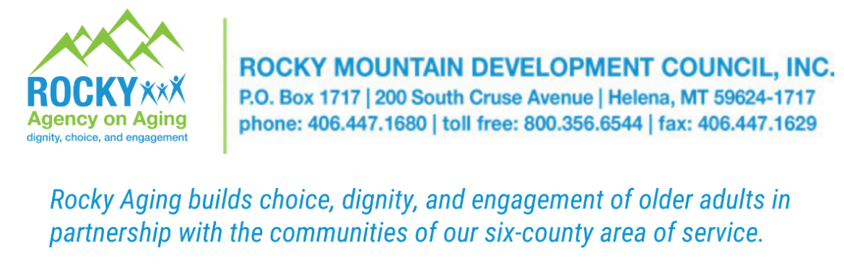
iPad Application

Name: ______________________________________

Date of Birth: ____________

Address: _____________________________________

Phone number: ________________________________

Email Address: _______________________________

Does the individual reside in a: Private Home Assisted Living Nursing Home
Other (please specify) _______________________________

Does the applicant have Wi-Fi available?
Yes No

Caregiver Contact Information
(Check here_________ if no caregiver and would like information on how to connect with a caregiver)

Name: ______________________________________

Address: _____________________________________

Phone number: ________________________________

Email Address: _______________________________

To combat social isolation among older Montanans. Rocky’s Agency on Aging will loan to qualified recipients, one Apple iPad per client living in the following counties:
Lewis & Clark, Jefferson, Broadwater, Meagher, Park, and Gallatin

Please return this application to Rocky’s Agency on Aging, P.O. Box 1717, Helena 59624
Or email to rmdc.areaiv@rmdc.net.

