**‘Care Share**

**June 2024**

June is marked by Medicare Fraud Prevention Week, which focuses on the actions everyone can take to prevent Medicare fraud, errors, and abuse. Medicare Fraud Prevention Week runs the week of June 5, or 6/5, because most people become eligible for Medicare when they turn 65. Medicare Fraud Prevention Week is hosted by the [Administration for Community Living](https://acl.gov/MFPW24) and the Senior Medicare Patrol, known as the SMP.

Medicare loses an estimated $60 billion each year due to fraud, errors, and abuse, though that number is impossible to measure. Every day, issues related to these problems affect people across the country, often costing them time, money, and well-being.

Medicare-related errors contribute to this annual loss even though errors can be honest health care billing mistakes. However, repeated errors by a doctor or provider could be considered a red flag of potential fraud or abuse if not corrected.  
When people steal from Medicare, it hurts us all and is big business for criminals. Some common examples of fraud, errors, or abuse could include:

* Charging for services or supplies that were not provided.
* Misrepresenting a diagnosis, a person’s identity, the service provided, or other facts to justify payment.
* Prescribing or providing excessive or unnecessary tests and services

Falling prey to consumer scams or health care fraud may mean that your Medicare number has been “compromised” because of medical identity theft. Stealing from Medicare leaves less available funds for those needing services now as well as those needing Medicare in the future.

## How to Take Part!

## The most effective way to stop Medicare fraud from occurring is to prevent it from happening in the first place. Learning how to prevent it and then sharing what you learn with others is how Medicare beneficiaries, caregivers, family members, partners and professionals, and the whole community can participate.

Contact your local SMP at 1-800-551-3191 or find us on Facebook! To contact SMP in another state go to <https://smpresource.org/contact-us/>

**Medicare Fraud Prevention**

Montana SMP is a program coordinated by Missoula Aging Services and partnered with local Area Agencies on Aging. This project was supported by grant #90MPPG0052 from the U.S. Administration for Community Living, Department of Health and Human Services, Washington D.C., 20201. Points of view or opinions do not necessarily represent official ACL policy.

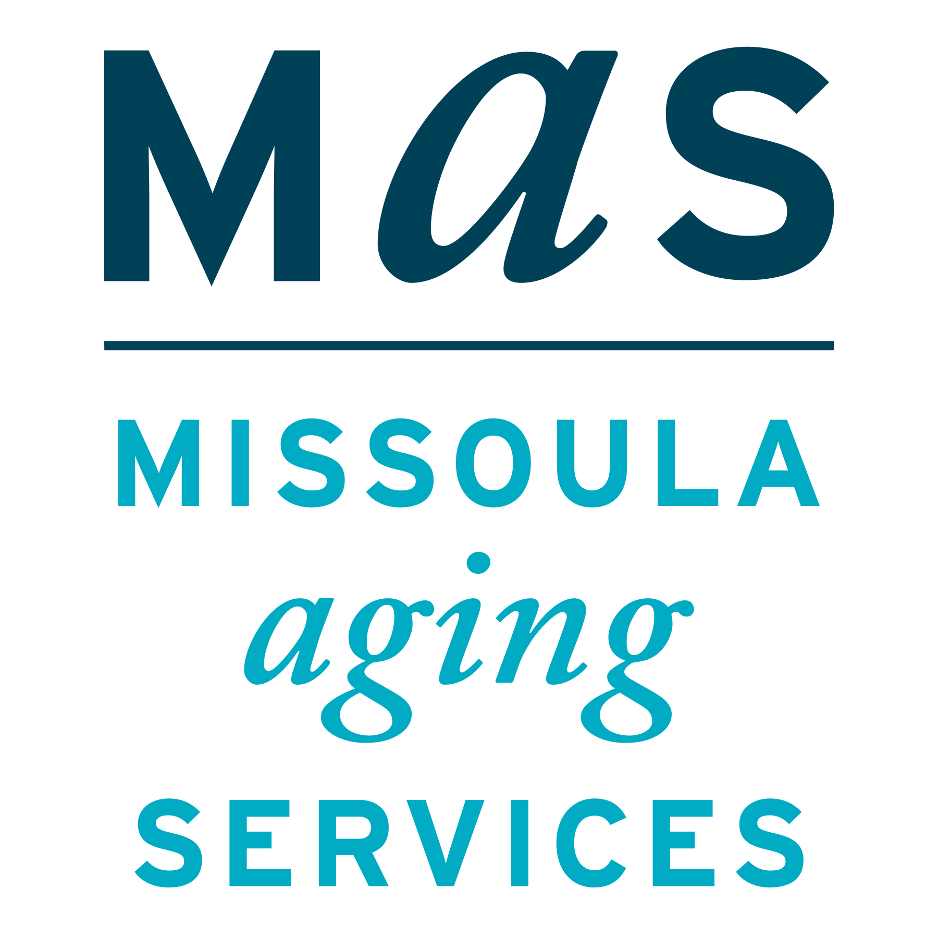

**NOTICE**

You may be in a select pool of Medicare beneficiaries contacted by NORC at the University of Chicago, for a study conducted on behalf of CMS. If you are contacted, note that they will not ask you for personally identifiable information or your Medicare number. **Never give your Medicare number out over an unsolicited phone call. If you are contacted by the NORC study but aren’t sure, you can call MT SMP at 1-800-551-3191 to check.**

## REPORT POTENTIAL GENETIC TESTING FRAUD, ERRORS, OR ABUSE IF:

* A company offers you “free” or “at no cost to you” testing without a treating physician’s order and then bills Medicare.
* A company uses “telemedicine” to offer testing to you over the phone and arranges for an unrelated physician or “teledoc” to order the test.
* You see on your Medicare Summary Notice (MSN) or Explanation of Benefits (EOB):
  + Charges (usually thousands of dollars) for a broad range of genetic tests that you did not request or even receive.
  + Charges for pharmacogenomic tests (to determine how you metabolize drugs) for drugs that do not apply to you.

The Senior Medicare Patrol (SMP) is ready to provide you with the information you need to PROTECT yourself from Medicare fraud, errors, and abuse; DETECT potential fraud, errors, and abuse; and REPORT your concerns. SMPs help educate and empower Medicare beneficiaries in the fight against health care fraud. Your SMP can help you with your questions, concerns, or complaints about potential fraud and abuse issues. It also provides information and educational presentations. To reach Montana Senior Medicare Patrol, call 1-800-551-3191 or visit www.smpresource.org.



Montana SMP has a Facebook Page! Follow and like to receive up to date information on Medicare and related fraud. Search for Montana Senior Medicare Patrol or go to <https://www.facebook.com/profile.php?id=61560025343575> and find us there.